Tutorial for PostgreSQL and pgAdmin
This document provides important details about using PostgreSQL in this course. PostgreSQL is a powerful, open source DBMS supporting a substantial part of the SQL standard. Many organizations use PostgreSQL in major information systems. This tutorial demonstrates installation of PostgreSQL on Windows 10 and usage of the pgAdmin 4 client software to execute SQL statements. This tutorial uses the latest stable versions of PostgreSQL (12.3) and pgAdmin (4) for Windows in June 2020.

1. Installation
You can download various versions of PostgreSQL from the organization’s website (postgresql.org) as shown in Figure 1. Select the Download → button to open the download page (Figure 2). Select the appropriate operating system to start the download process. This tutorial demonstrates installation in Windows 10 so Windows was selected. The Windows Installers page (Figure 3) shows the PostgreSQL versions supported on Windows 10. Click the Download the Installer link to open the EDB page for Windows PostgreSQL installers (Figure 4). The installer should be begin downloading. Keep the installation file if asked.

Figure 1: postgresql.org Opening Page
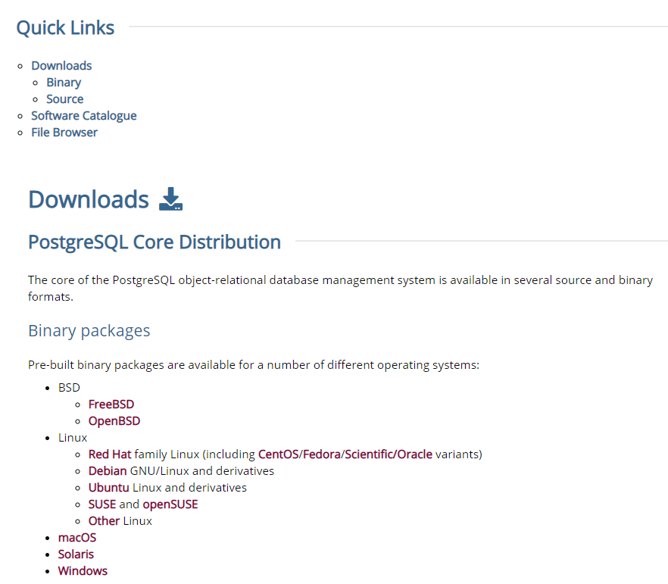
Figure 2: PostgreSQL Download Page
After downloading completes, you can start the installation by double clicking the .exe file (postgresql-12.3-1-windows-x64.exe in this tutorial). Let the installer take control (respond yes) to begin installation. Select Next > for the first installation window (Figure 5). In the next window, choose the installation directory (Figure 6). Follow the remaining installation windows (Figures 7 to 14) to complete the installation. In the Password window (Figure 9), you must enter a password for the superuser (postgres). You must remember this password as you will need to use the password when starting PostgreSQL. After the last installation window (Figure 14), you can skip the Stack Builder additional installation by clicking the Cancel button (Figure 15). You can use Stack Builder later if you want to install other components.
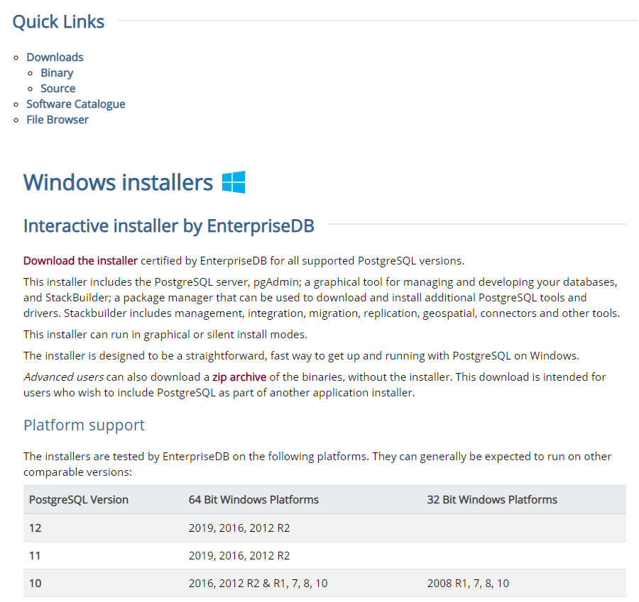
Figure 3: PostgreSQL Windows Installer Page
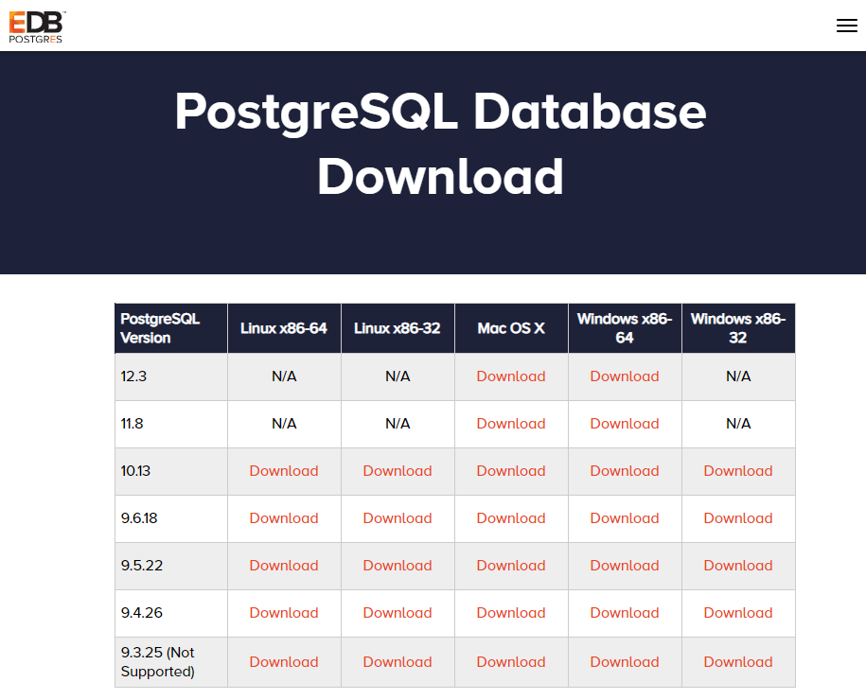
Figure 4: EDB Windows Installer Page for PostgreSQL
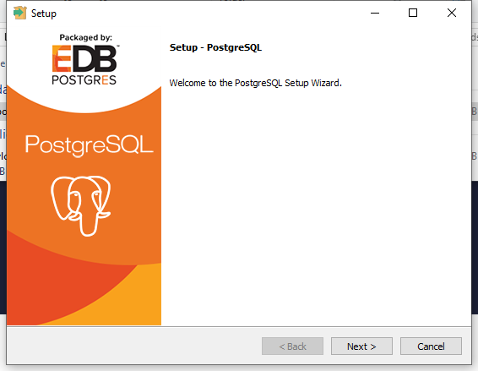
Figure 5: First Installation Window for PostgreSQL
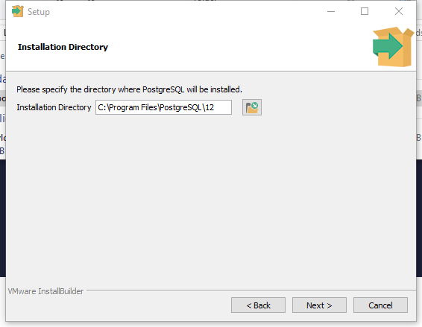
Figure 6: Second Installation Window to Select Directory
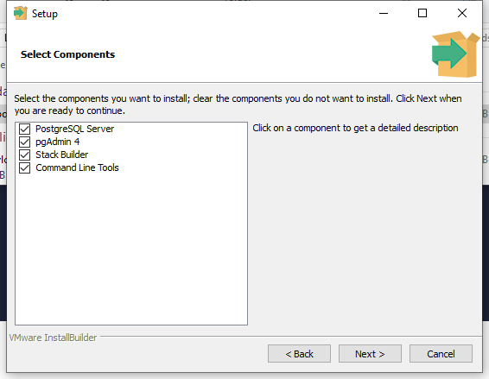
Figure 7: Third Installation Window to Select Components
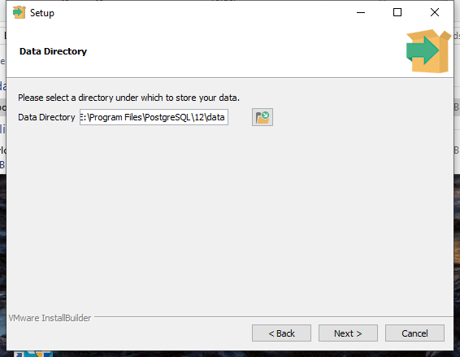
Figure 8: Fourth Installation Window to Select Data Directory
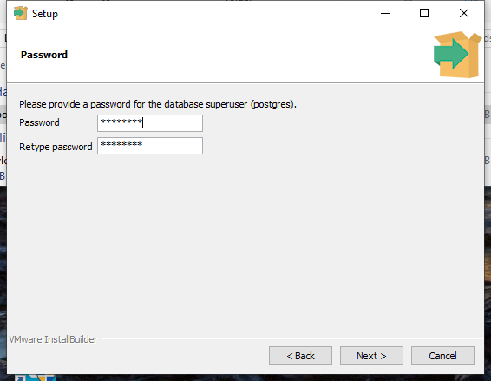
Figure 9: Fifth Installation Window to Enter Superuser Password
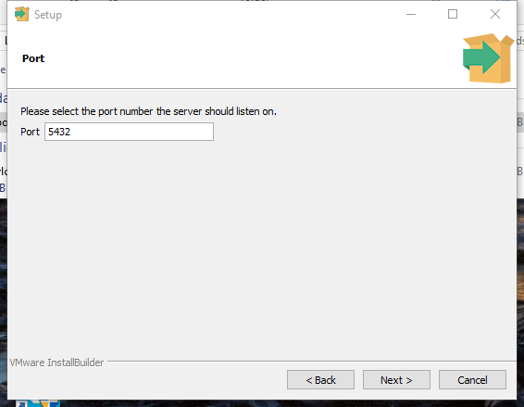
Figure 10: Sixth Installation Window to Enter Port
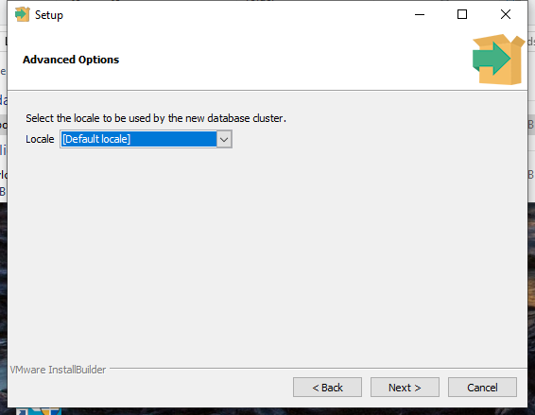
Figure 11: Seventh Installation Window to Enter Locale
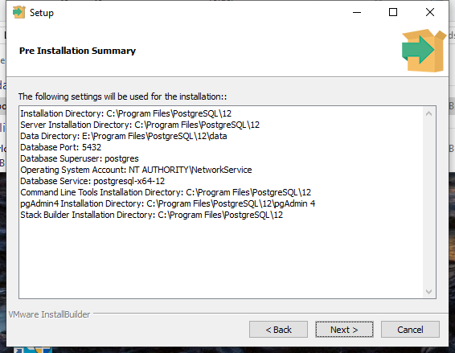
Figure 12: Eigth Installation Window to View Installation Summary
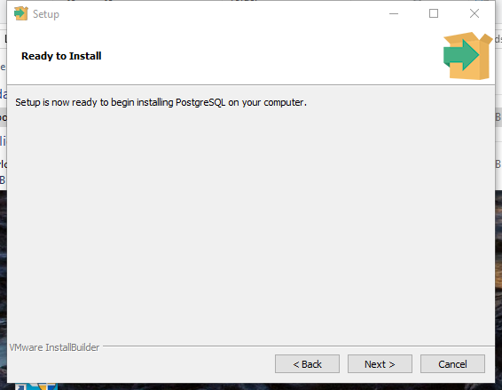
Figure 13: Ninth Installation Window to Start Installation
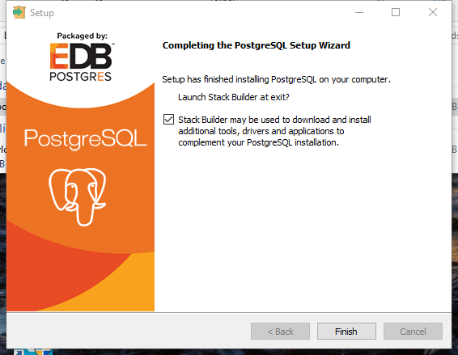
Figure 14: Tenth Installation Window to Finish Installation
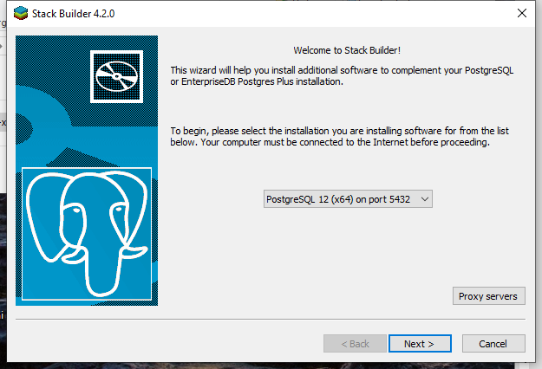
Figure 15: Stack Builder Installation Window (Cancel)

2. Creating and Connecting to a Database using pgAdmin 4
After installation, you can use pgAdmin, the PostgreSQL client, to create and connect to databases. Start pgAdmin 4 in the Windows programs list (Figure 16) in the Windows menu. You can create a short cut to pgAdmin 4 by dragging the pgAdmin 4 icon to the desktop. After pgAdmin 4 begins, you need to enter the master password that you provided in the installation process (Figure 17). After entering the password, pgAdmin 4 opens with the Servers object without expansion (Figure 18). After you expand the Servers object, you may need to provide the master password again. After the Servers object expands, you can expand the Databases object and Schemas object inside the Databases object (Figure 19).
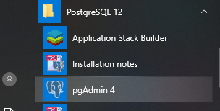
Figure 16: Selecting pgAdmin 4 in the Windows Program List
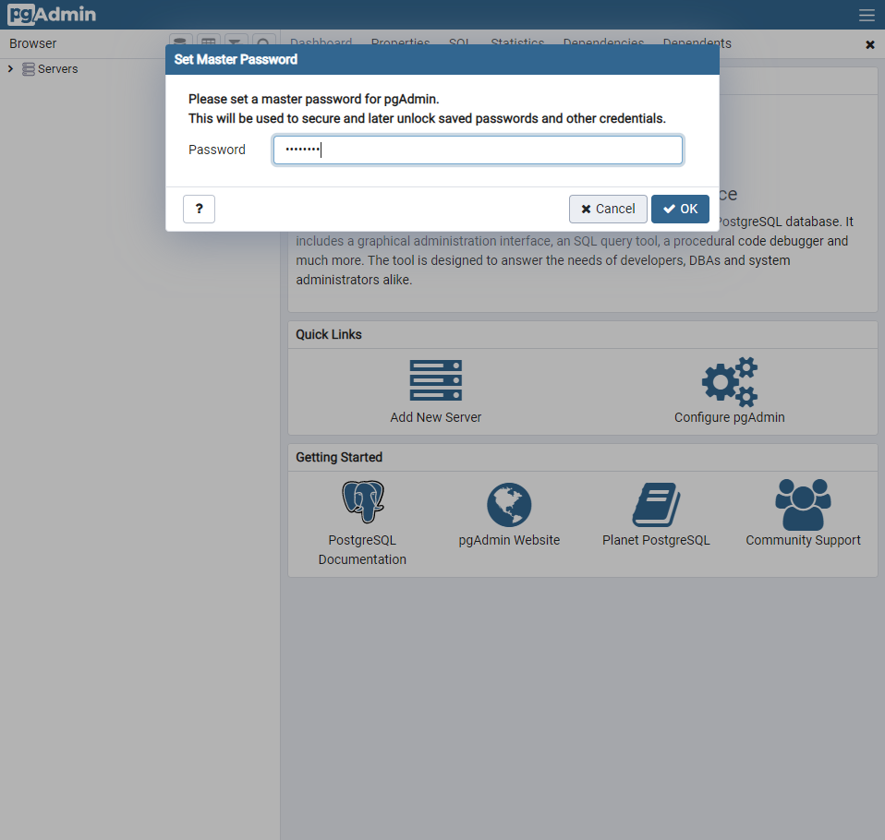
Figure 17: Enter Master Password Window
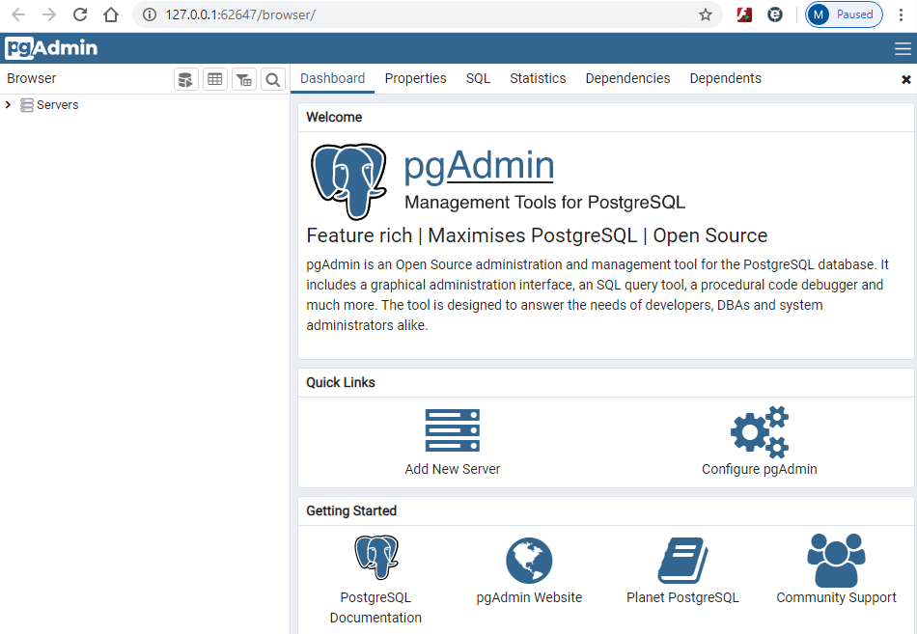
Figure 18: pgAdmin Showing the Servers Object without Expansion
Although you can use the default postgres database to execute SQL statements, I recommend creating separate databases for each database used in the course. With separate databases, you will not have conflicts among common table names in the course databases. Follow these steps to create a new database for the university database tables and then connect to the new database so that you can enter SQL statements to create and populate tables.
- Right click on the Databases (1) object inside the PostgreSQL 12 object (Figure 20). Select Create -> Database …
- Enter the database name (UnivDB) and click the Save button (Figure 21).
- Expand the Databases object to see the UnivDB database (Figure 22).
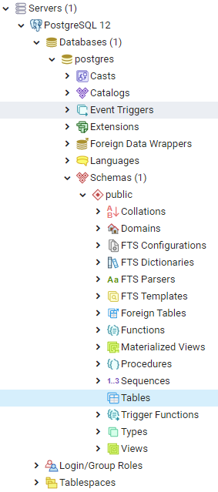
Figure 19: Expansion of Databases and Schemas Objects
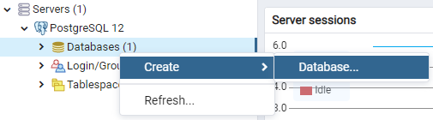
Figure 20: Create New Database
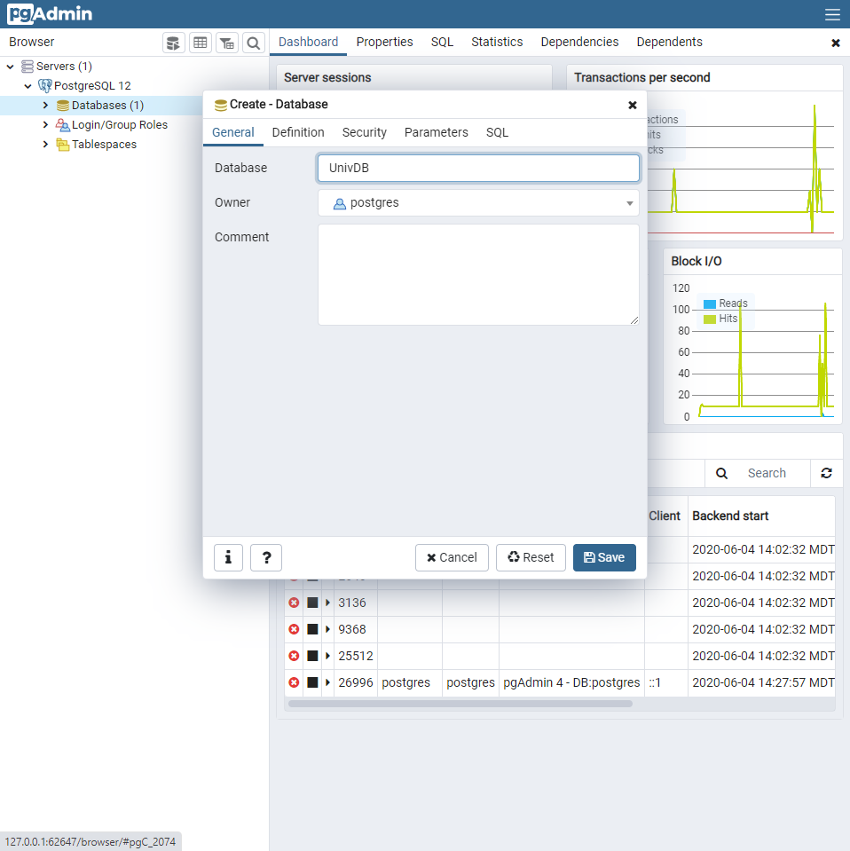
Figure 21: Enter Database Name Window
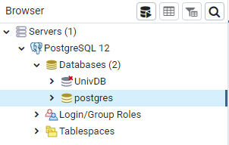
Figure 22: Expanded Databases Object showing UnivDB Database

3. Executing SQL Statements
pgAdmin 4 provides the Query Tool to enter and execute SQL statements. You open the Query Tool for each database in which you want to execute SQL statements. Follow these steps to create and populate the university database tables. For other databases, you can create the database as described in the previous section and the use the Query Tool to execute SQL statements.
- Expand the UnivDB object (Figure 23). The click the Query Tool () to open the Query Window for the UnivDB database. Alternatively, you can right click on the UnivDB object and select Query Tool.
- The Query Window opens showing a new panel (top right) for the UnivDB database (Figure 24).
- Copy and paste the CREATE statements for the University Database. In Course 1, you can find these statements in Module 3. Click the Run button () to execute the statements (Figure 25).
- Use the Clear Window item (Figure 26) in the Clear button () to clear the Query Window. Respond Yes to the prompt about discarding the current changes in the Query Window (Figure 27).
- Copy and paste the INSERT statements for the University Database. In Course 1, you can find these statements in Module 3. Click the Run button to execute the statements (Figure 28).
- Expand the Tables object (Figure 29) to see the list of tables created.
- You can count the rows to verify the execution of the INSERT statements. Right click the Student table and select Count Rows (Figure 30).

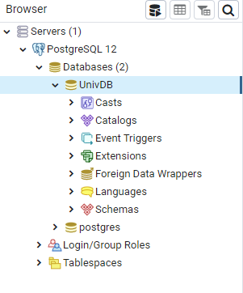
Figure 23: Expanded UnivDB Object showing Query Tool Button
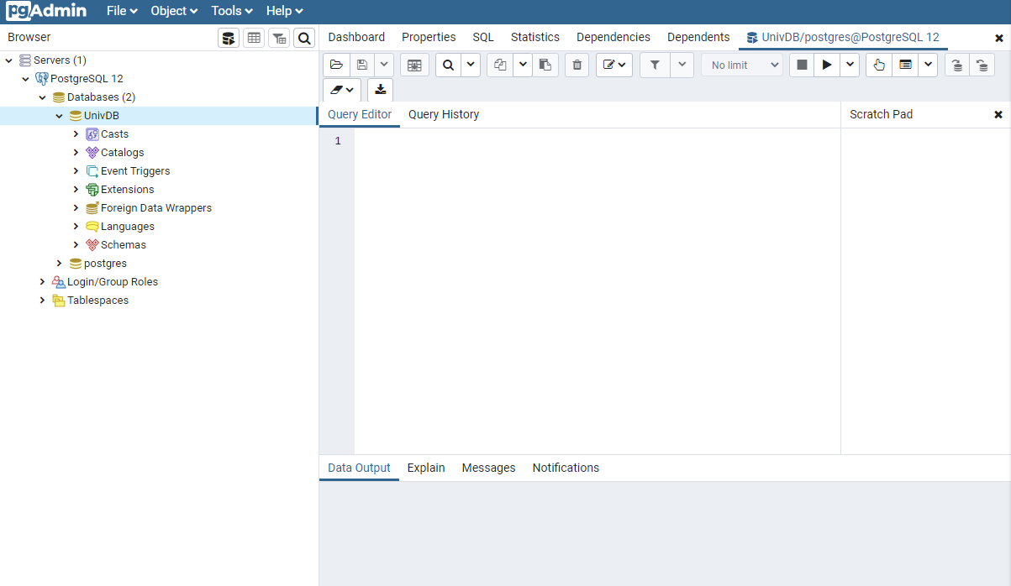
Figure 24: Expanded UnivDB Object with Query Editor Window
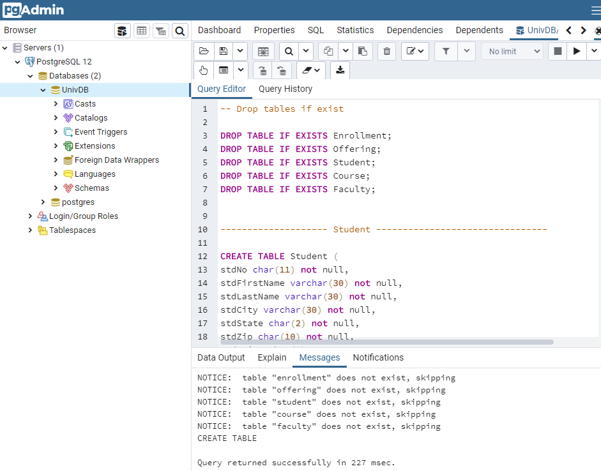
Figure 25: Query Editor Window with Executed SQL Statements to Create Tables
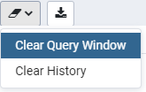
Figure 26: Clear Query Window Selection
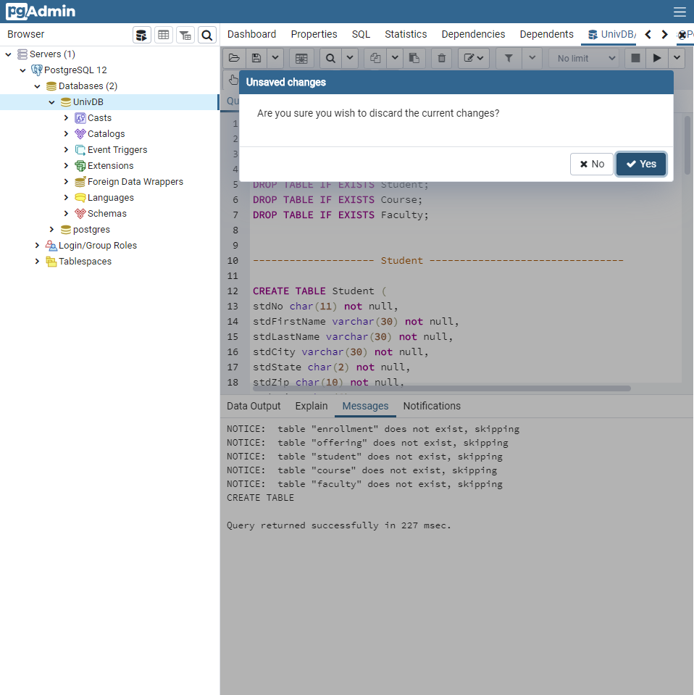
Figure 27: Selecting Yes to Clear Query Window
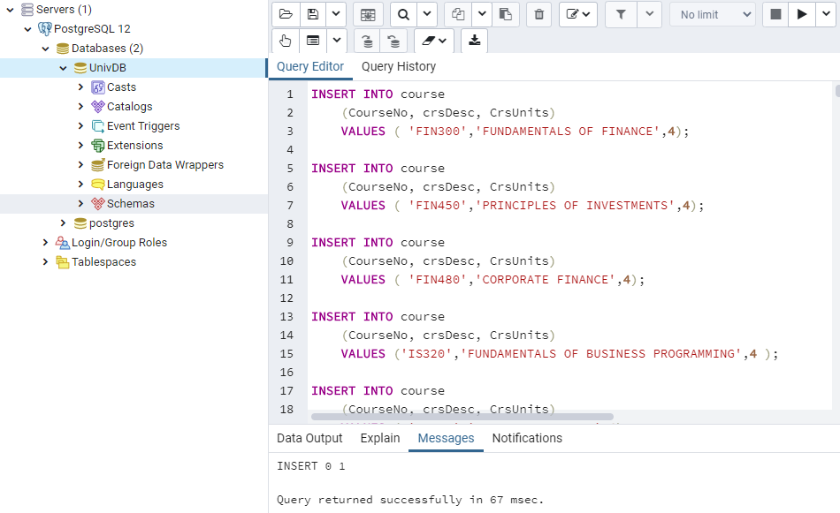
Figure 28: Query Editor Window with Executed SQL Statements to Populate Tables
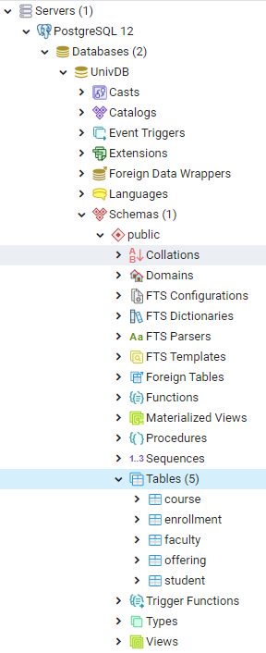
Figure 29: Expansion of Tables Object in the UnivDB Database
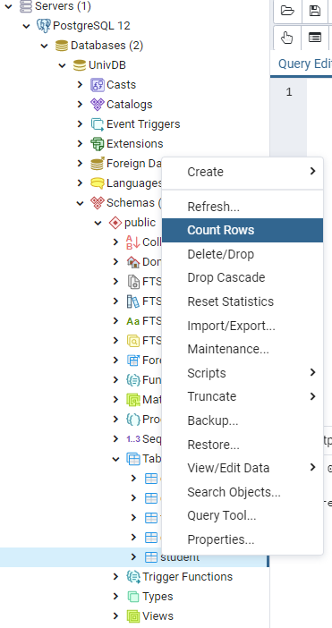
Figure 30: Counting Rows Selection for the Student Table

4. Using pgAdmin 4 for Assignments
After completing this tutorial, you should be confident to use pgAdmin for work on SQL assignments. To use pgAdmin 4, you should open pgAdmin 4, expand the database that you previously created, and open the Query Tool for the database to execute SQL statements. If you have not created the database used in the assignment, you should follow the steps to create and populate a new database before executing SQL statements for the assignment.

